**Mini Project Report**

on

**HOT STANDBY ROUTER PROTOCOL**

Submitted to

### Jawaharlal Nehru Technological University Anantapur, Ananthapuramu

in partial fulfillment of the requirements for the award of the degree of

**BACHELOR OF TECHNOLOGY**

**IN**

**INFORMATION TECHNOLOGY**

Submitted by

|  |  |
| --- | --- |
| **A . Siva Teja** | **21121A1208** |
| **M . Manju Bhargavi** | **21121A1257** |
| **E . Sravanthi** | **21121A1226** |
| **C . Mahidhar Reddy** | **21121A1221** |
| **A . Gowthami** | **21121A1204** |



Department of Information Technology

SREE VIDYANIKETHAN ENGINEERING COLLEGE

(AUTONOMOUS)

(Affiliated to JNTUA, Ananthapuramu, Approved by AICTE, Accredited by NBA & NAAC) Sree Sainath Nagar, Tirupati – 517 102, A.P., INDIA

2022-2023

**Institute Vision and Mission**

**VISION**

To be one of the Nation’s premier Engineering Colleges by achieving the highest order of excellence in Teaching and Research.

**MISSION**

* To foster intellectual curiosity, pursuit and dissemination of knowledge.
* To explore students’ potential through academic freedom and integrity.
* To promote technical mastery and nurture skilled professionals to face competition in ever increasing complex world.

**DEPARTMENT OF INFORMATION TECHNOLOGY**

**VISION**

To become a nationally recognized quality education center in the domain of Computer Science and Information Technology through teaching, training, learning, research and consultancy.

**MISSION**

* The Department offers undergraduate program in Information Technology to produce high quality information technologists and software engineers by disseminating knowledge through contemporary curriculum, competent faculty and adopting effective teaching-learning methodologies.
* Igniting passion among students for research and innovation by exposing them to real time systems and problems
* Developing technical and life skills in diverse community of students with modern training methods to solve problems in Software Industry.
* Inculcating values to practice engineering in adherence to code of ethics in multicultural and multi discipline teams.

**PROGRAM EDUCATIONAL OBJECTIVES**

After few years of graduation, the graduates of B. Tech. (IT) Program will be:

|  |  |
| --- | --- |
| 1. | Enrolled or completed higher education in the core or allied areas of Computer Science and Information Technology or management. |
| 2. | Successful entrepreneurial or technical career in the core or allied areas of Computer Science and Information Technology. |
| 3. | Continued to learn and to adapt to the world of constantly evolving technologies in the core or allied areas of Computer Science and Information Technology. |

**PROGRAM OUTCOMES**

On successful completion of the Program, the graduates of B. Tech. (IT) Program will be able to:

|  |  |
| --- | --- |
| 1. | Apply the knowledge of mathematics, science, engineering fundamentals, and an engineering specialization to the solution of complex engineering problems. |
| 2. | Identify, formulate, research literature, and analyze complex engineering problems reaching substantiated conclusions using first principles of mathematics, natural sciences, and engineering sciences. |
| 3. | Design solutions for complex engineering problems and design system components or processes that meet the specified needs with appropriate consideration for the public health and safety, and the cultural, societal, and environmental considerations. |
| 4. | Use research-based knowledge and research methods including design of experiments, analysis and interpretation of data, and synthesis of the information to provide valid conclusions. |
| 5. | Create, select, and apply appropriate techniques, resources, and modern engineering and IT tools including prediction and modeling to complex engineering activities with an understanding of the limitations. |
| 6. | Apply reasoning informed by the contextual knowledge to assess societal, health, safety, legal and cultural issues and the consequent responsibilities relevant to the professional engineering practice. |
| 7. | Understand the impact of the professional engineering solutions in societal and environmental contexts, and demonstrate the knowledge of, and need for sustainable development. |
| 8. | Apply ethical principles and commit to professional ethics and responsibilities and norms of the engineering practice. |
| 9. | Function effectively as an individual, and as a member or leader in diverse teams, and in multidisciplinary settings. |
| 10. | Communicate effectively on complex engineering activities with the engineering community and with society at large, such as, being able to comprehend and write effective reports and design documentation, make effective presentations, and give and receive clear instructions. |
| 11. | Demonstrate knowledge and understanding of the engineering and management principles and apply these to one’s own work, as a member and leader in a team, to manage projects and in multidisciplinary environments. |
| 12. | Recognize the need for, and have the preparation and ability to engage in independent and life-long learning in the broadest context of technological change. |

**PROGRAM SPECIFIC OUTCOMES**

On successful completion of the program, the graduates of B.Tech. (IT) program will be able to:

|  |  |
| --- | --- |
| **PSO1:** | Design and develop database systems, apply data analytics techniques, and use advanced databases for data storage, processing and retrieval. |
| **PSO2:** | Apply network security techniques and tools for the development of highly secure systems. |
| **PSO3:** | Analyze, design and develop efficient algorithms and software applications to deploy in secure environment to support contemporary services using programming languages, tools and technologies. |
| **PSO4:** | Apply concepts of computer vision and artificial intelligent for the development of efficient intelligent systems and applications. |

**HOT STANDBY ROUTER PROTOCOL**

The Hot Standby Router Protocol (HSRP) is a routing protocol designed to provide automatic failover and redundancy in a local area network (LAN) environment. It allows multiple routers to work together in a group, with one router acting as the active router and others as standby routers. In the event of a failure, the standby routers. In the event of a failure, the standby routers seamlessly take over the responsibilities of the active router, ensuring uninterrupted network connectivity.

HSRP allows you to configure two or more routers as standby routers and only a single router as an active router at a time. All the routers in a single HSRP group shares a single MAC address and IP address, which acts as a default gateway to the local network. The Active router is responsible for forwarding the traffic. If it fails, the Standby router takes up all the responsibilities of the active router and forwards the traffic.

This documentation presents the implementation details of HSRP in a mini project scenario, including the network topology, configuration steps, testing, and verification.

**Some important terms related to HSRP:**

* Virtual IP: IP address from local subnet is assigned as default gateway to all local hosts in the network.
* Virtual MAC address: MAC address is generated automatically by HSRP. The first 24 bits will be default CISCO address (i.e., 0000.0c). The next 16 bits are HSRP ID (i.e., 07.ac). The next 8 bits will be the group number in hexadecimal. e.g- if the group number is 10 then the last 8 bits will be 0a.

Example of virtual MAC address –

0000.0c07.ac0a

* Hello messages: Periodic messages exchanged by active and standby routers. These messages are exchanged after every 3 seconds telling the state of router.
* Hold down timer: Its default value is 10 seconds i.e., roughly 3 times the value of hello message. This timer tells us about the router that how much time will the standby router waits for hello message if it is not received on time.
* Priority: By default, the priority value is 100. It is helpful when the active router comes back after falling down, we can change the priority of standby router (which has become the active router after the original active router is down) to less than 100 therefore it again becomes standby router.
* Preempt: It is a state in which the standby router automatically becomes the active router.

The objective of this mini project is to demonstrate the functionality and benefits of HSRP by setting up a redundant network infrastructure. The project aims to showcase the failover capability of HSRP and its ability to provide uninterrupted network services in case of a router failure.

**WORKING:**

Members having same group ID are the members of same group. One of the members of the group will be elected as the active router while others remain as standby routers. The virtual IP is configured as default gateway of all the hosts in the local subnet and the active router is responsible for forwarding the traffic of local hosts. If the active router goes down then the hello messages are not exchanged between the active and the standby routers therefore the standby router waits until the hold-down timer time. As soon as the hold down time is finished, the standby router will become the active router and take up all the responsibilities of active router. This is known as prempt.

If in case the original active router comes back then we can decrease the priority of the standby router so that it will become the standby router again.

**Hot Standby Router Protocol Features and Functionality:**

* HSRP stand for Hot Standby Router Protocol.
* HSRP used for 100% uptime network.
* Provide Network Redundancy for IP network.
* Used more than one gateway to balance the traffic for Client area.
* In this mechanism 2 or more router act as a single virtual router to maintain failover.
* Group Router Exchange status messages between each other to balance the traffic.
* The Hello Times are 3 sec and 10 messages.

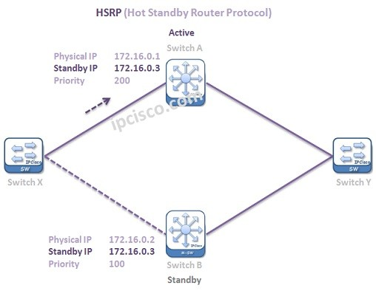

With Hot Standby Router Protocol mechanism, even if a failure occurs on one device in the HSRP Group, then the traffic goes through on another device in that Group, through an alternative path.

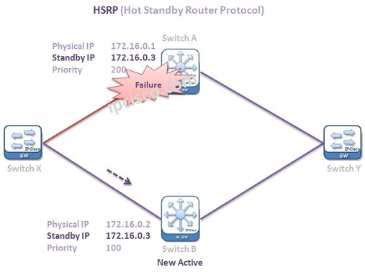

**Hot Standby Router Protocol**provides this by using a Virtual IP address and a MAC address as a Gateway of multiple path alternatives. The traffic is always going to the Virtual IP address, Virtual Gateway. So, the traffic flow is independent from a device. This avoids single point of failure on the networks.

By the way,**HSRP Group numbers** is mention at the beginning of the configuration after “**standby**” keyword. There can be multiple groups of **Hot Standby Router Protocol**on an interface.

**HSRP States**

Listed below are the different Hot Standby Router Protocol states:

1. Initial – when the link comes up.
2. Learn – the HSRP device is trying to learn VIP.
3. Listen – the device knows the VIP and listens for hello messages from other HSRP devices.
4. Speak – the device sends hello messages and participates in the election to become the active router.
5. Standby – the device is patiently waiting to take over should the active router fails.
6. Active – the device receives the data intended for VIP.

**HSRP Router Roles**

Hot Standby Router Protocol works with HSRP Groups. For each group, there are different routers that has different roles. These roles are:

1. Active Router
2. Standby Router
3. Listening Routers

* The Active Router is the router that the traffic flow goes through. It is the router that provides active traffic flow.
* The Standby Router is the backup of Active Router. When the active router fails then this router becomes Active and the traffic goes through this router.
* Lastly the **Listening Routers** are the other routers that are participating in the HSRP group.

**Hot Standby Router Protocol (HSRP) has 2-versions:**

version 1: The messages are multicast at 224.0.0.2 and uses the UDP port 1985. This version allows group number range from 0 to 255.

version 2: The messages are multicast at 224.0.0.102 and uses the UDP port 1985. This version allows group number range from 0 to 4095.

**DRDM Mechanism:**

* This is called as Dynamic Routing Discovery Mechanism to maintain the network traffic.
* This mechanism is for Network host
* Many mechanisms do not provide network resiliency and same many protocols are not
* Because it is not possible for every host
* And lots of using single gateway over a network
* There are many types of Dynamic Routing mechanism like routing protocols.

**Advantages of HSRP**:

* High Availability: HSRP provides redundancy for the default gateway, ensuring that if the active router fails, a standby router takes over seamlessly. This minimizes network downtime and ensures uninterrupted connectivity for end devices.
* Load Balancing: HSRP allows multiple routers to share the traffic load by distributing the network traffic among the routers in the group. This helps prevent congestion on a single router and improves overall network performance.
* Transparent Failover: HSRP enables transparent failover, meaning that end devices connected to the network do not need to reconfigure their settings or be aware of the failover process. The standby router automatically assumes the active role without disrupting the network operation.
* Simple Configuration: Configuring HSRP is relatively straightforward. Once the routers are configured with the appropriate HSRP settings, they automatically elect the active and standby routers based on priority and other factors. This simplifies the configuration and management of redundant default gateways.
* Scalability: HSRP allows for the inclusion of multiple routers in a group, providing scalability to accommodate larger networks. Additional routers can be added to the HSRP group to handle increased traffic or to provide additional redundancy.
* Flexibility: HSRP is vendor-specific to Cisco devices, but it is widely supported across their product range. This allows for flexibility in designing and implementing a network infrastructure using Cisco equipment while maintaining high availability.
* Monitoring and Health Checks: HSRP routers exchange hello messages to monitor the health and status of each other. This continuous monitoring ensures that any failure or unavailability of the active router is detected promptly, triggering a failover to a standby router.
* Preemption: HSRP supports preemption, allowing a higher-priority router to automatically take over as the active router when it becomes available. This ensures that the most capable router always serves as the active gateway, maximizing network efficiency and reliability.

**Disadvantages of HSRP:**

While HSRP offers numerous advantages, it's important to consider its potential disadvantages:

* Vendor-Specific Implementation: HSRP is primarily implemented in Cisco networking equipment, which means it may not be compatible with non-Cisco devices or multi-vendor environments. This vendor lock-in can limit flexibility and interoperability options for organizations using different networking equipment.
* Single Active Router: HSRP allows for only one active router at a time. In scenarios where there are multiple routers capable of handling traffic, HSRP does not distribute the traffic evenly among them. This can lead to underutilization of resources and potential performance bottlenecks.
* Limited Load Balancing: While HSRP supports load balancing to some extent, it is primarily designed for redundancy rather than equal distribution of traffic. The load balancing capabilities of HSRP are not as advanced as other protocols like GLBP (Gateway Load Balancing Protocol), which provide more efficient load balancing algorithms.
* Stateful Failover: HSRP uses stateful failover, which means that the standby router takes over the exact state of the active router. This process involves synchronizing routing tables, ARP tables, and other information. In some cases, this synchronization process can introduce delays and impact network performance during failover.
* Complexity and Configuration: Although HSRP configuration is relatively straightforward, it still requires proper planning and configuration on each participating router. The setup and management of HSRP can be complex, especially in large-scale networks with multiple HSRP groups and numerous routers.
* Single Point of Failure: While HSRP provides redundancy for the default gateway, it relies on a shared virtual IP address. If the HSRP group encounters issues with the virtual IP address, such as misconfiguration or network conflicts, it can result in a single point of failure and impact network availability.
* Limited Network Convergence: HSRP may experience slower network convergence compared to some other protocols. Convergence refers to the time it takes for the network to stabilize after a failure. HSRP failover times can vary depending on factors such as the number of routers in the group and the network topology.
* HSRP Split-Brain Scenario: In certain scenarios, such as network partitioning or communication issues between routers, HSRP can encounter a split-brain situation. This occurs when multiple routers simultaneously assume the role of the active router, leading to network instability and potential routing issues.

**Network Topology:**

The network topology for this mini project consists of the following components:

1. Routers 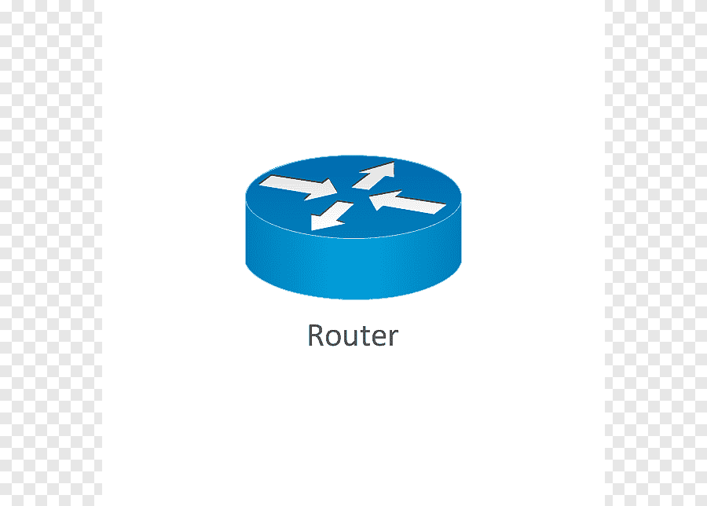 2. Switches



3 . PCs

**Configuration Steps:**

* Connect the network devices as per the network topology diagram.
* Configure IP addresses and default gateways on PCs.
* Configure IP addresses on the interfaces of Router A and Router B.
* Configure HSRP on both routers using the following commands:

RouterA(config)# interface <interface>

RouterA(config-if)# standby group <group number>

RouterA(config-if)# standby <group number> ip <virtual IP>

RouterA(config-if)# end

**Testing and verification:**

* Ping the virtual IP address configured for HSRP from PCs..
* Verify that the ping is successful and that the active router is Router A.
* Shutdown the active router's interface connected to the LAN.
* Observe that the standby router takes over as the active router.
* Ping the virtual IP address again and verify that the ping is still successful.
* Bring up the interface of the previously shutdown router .
* Observe that Router A becomes the active router again.
* Ping the virtual IP address once more and verify successful connectivity.

**Step Wise procedure for HSRP implementation:**

**STEP 1:** Open cisco packet tracer and drag a 2621XM router from network devices to the screen.



**STEP 2:** Similarly add two more routers to the setup.

**STEP 3:** Now add a switch to the setup.



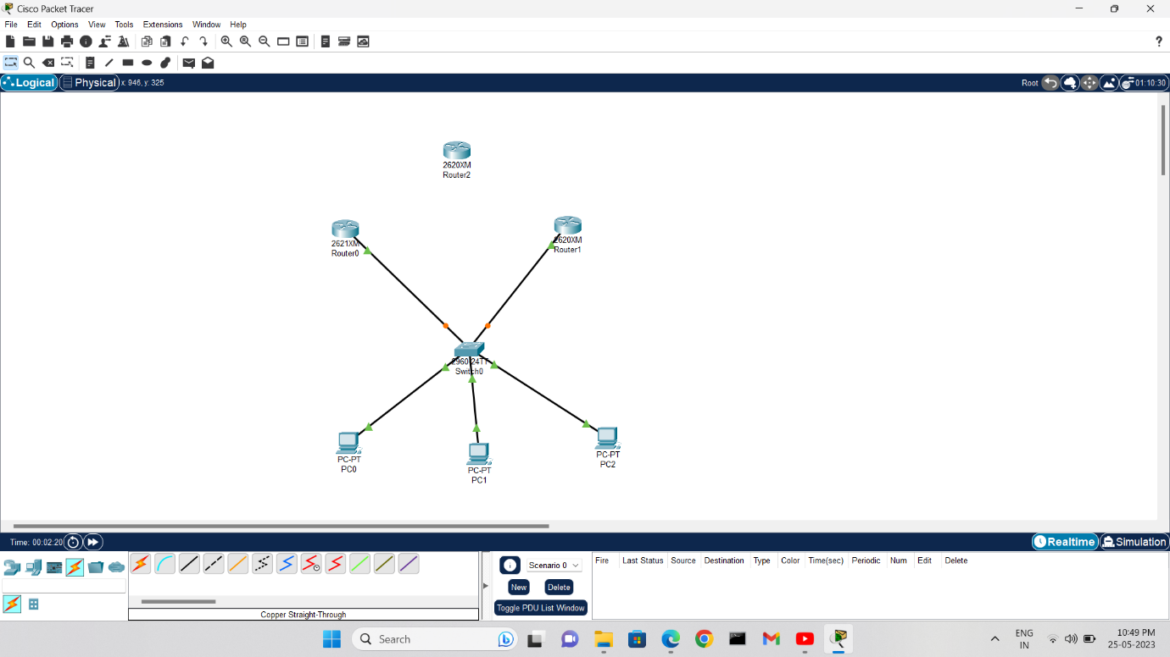**STEP 4:**  Now add some end devices like PC’s to the network.

**STEP 5:** Now connect all the devices with the help of a copper straight wire. Here we have not connected a router to the network because it acts as a standby router to the network without any physical connection with the network.

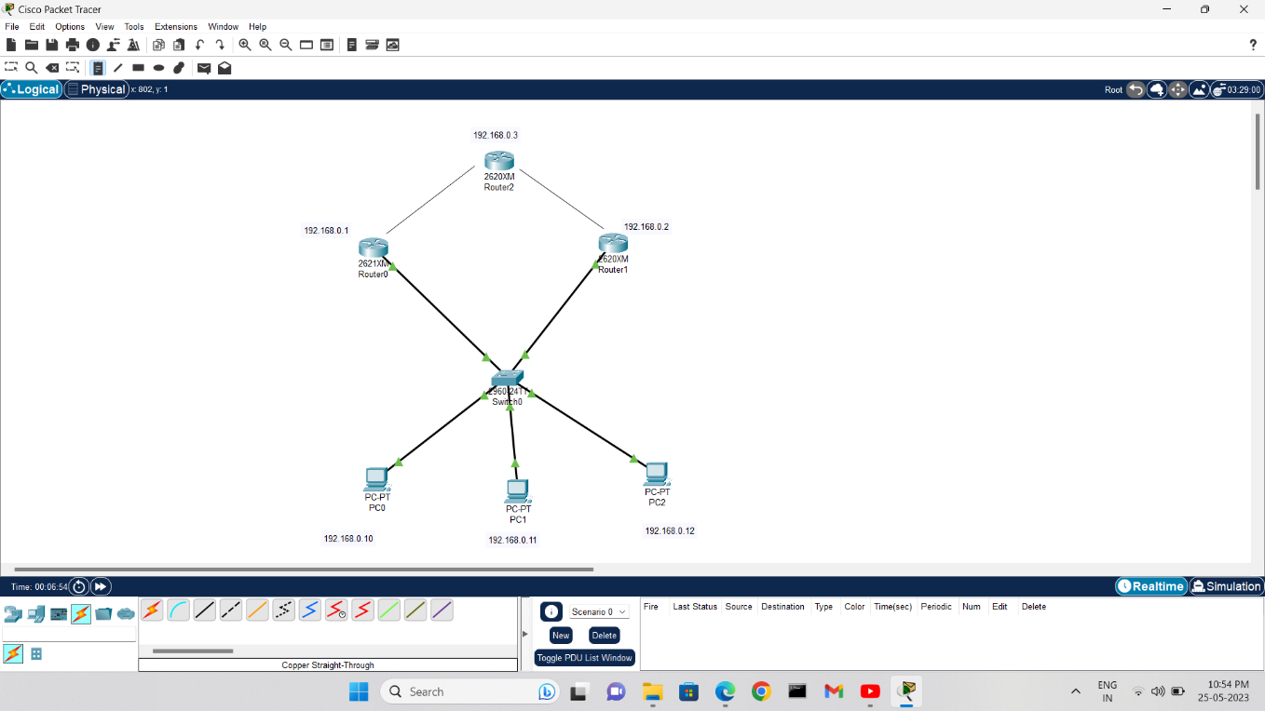

**STEP 6:** Now add the ip addresses of the devies in the form of text for better understanding.

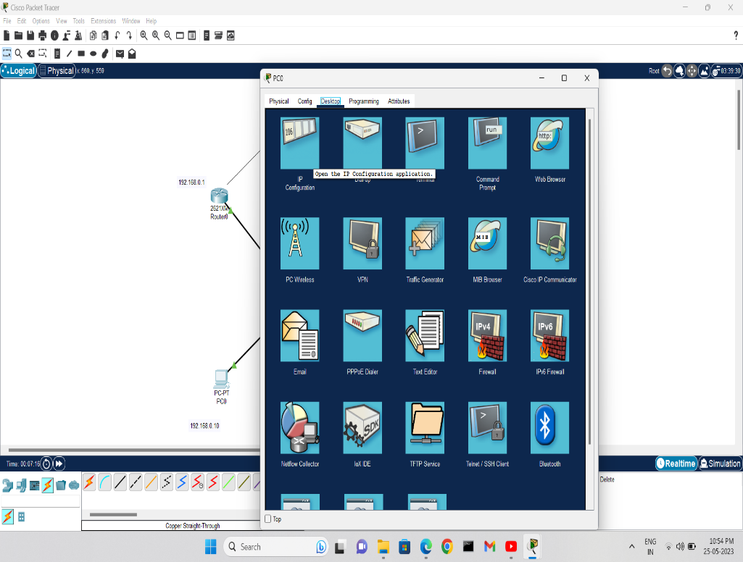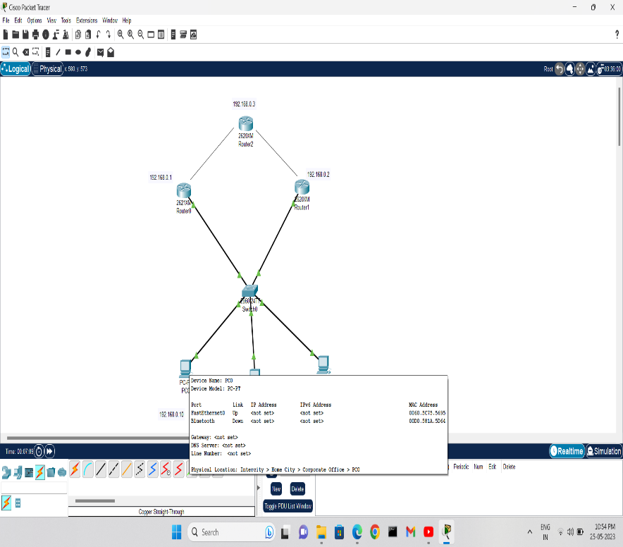

**STEP 7:** Now click on a pc and go the desktop menu. Select ip configure from the desktop menu.

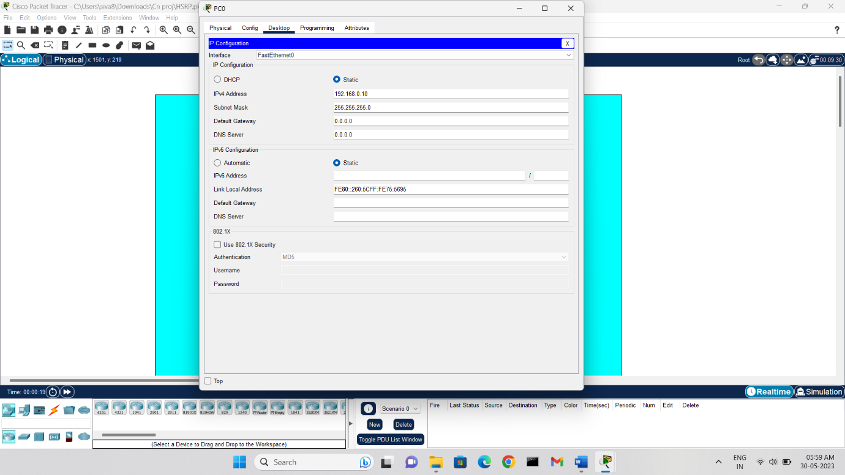

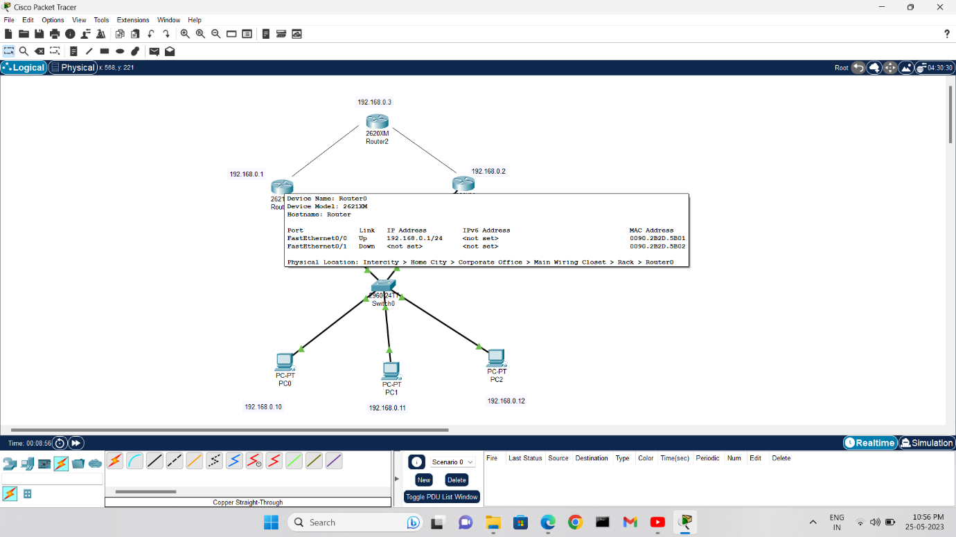**STEP 8:** Now we can assign the ip address for that pc. Similarly assign the ip address for all the pc’s in the network.

**STEP 9 :** Now it’s for the configuration of the router. For that first we need to click a router which has the physical connection with the network.

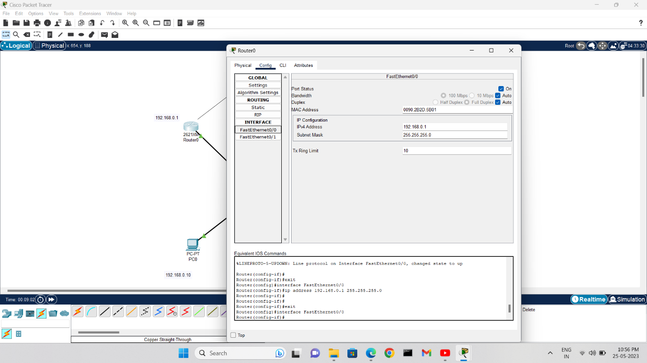

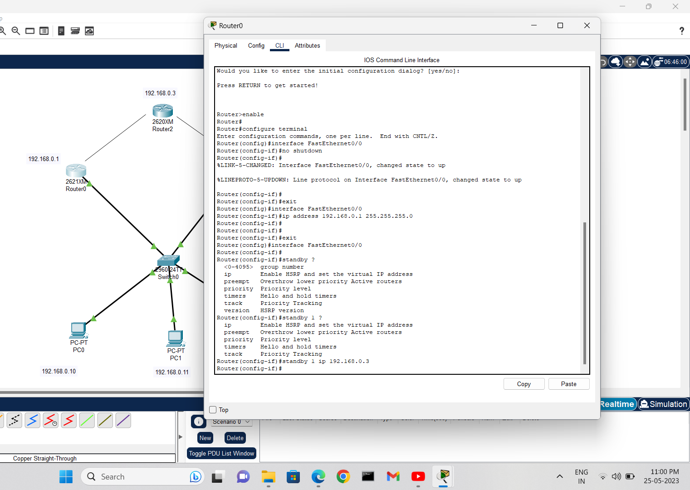**STEP 10:** After clicking on the router select ‘config’. Then select the path on which we have established the connection with the network. First enable the path and assign the ip address. Similarly perform these operations on the other router also which has the physical connection with the network.

**STEP 11:** Now it’s time for the configuration of the standby router with the network. Click a router in the network and perform the following commands through the CLI.

* interface port_name (Here FastEthernet0/0)
* standby ? (To check the previous standby commands)
* standby group_name (Here we have given the group name as 1)
* standby group_name ip ip_address(Here ip address=192.168.0.3)

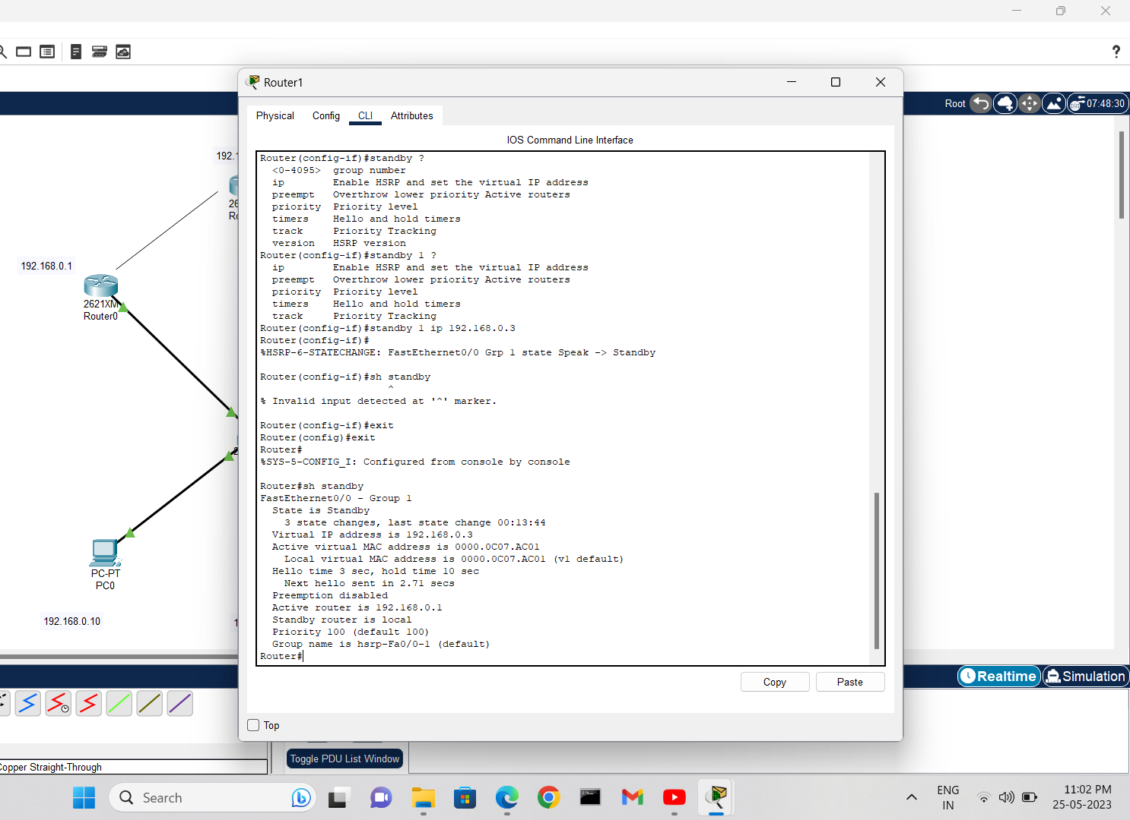By following these commands we can add ‘n’ standby routers to the network according to our need.

**STEP 12:** We can check the configured standby address by the command ‘sh standby’. Similarly configure the standby router for the another router in the network also.



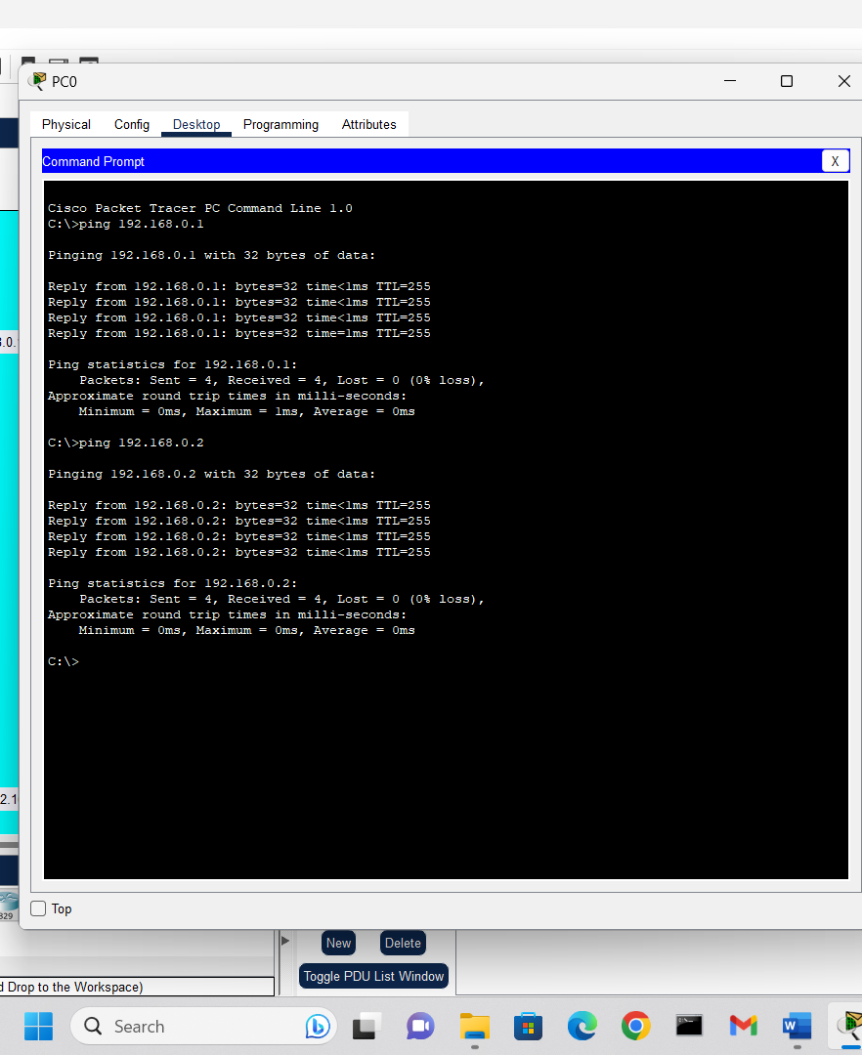**STEP 13:** Now click any pc in the network and select command prompt.

**STEP 14:** Now check for the uninterrupted transfer of the data packets to both the routers in the network. Here we can see that the data packets were transmitted successfully.

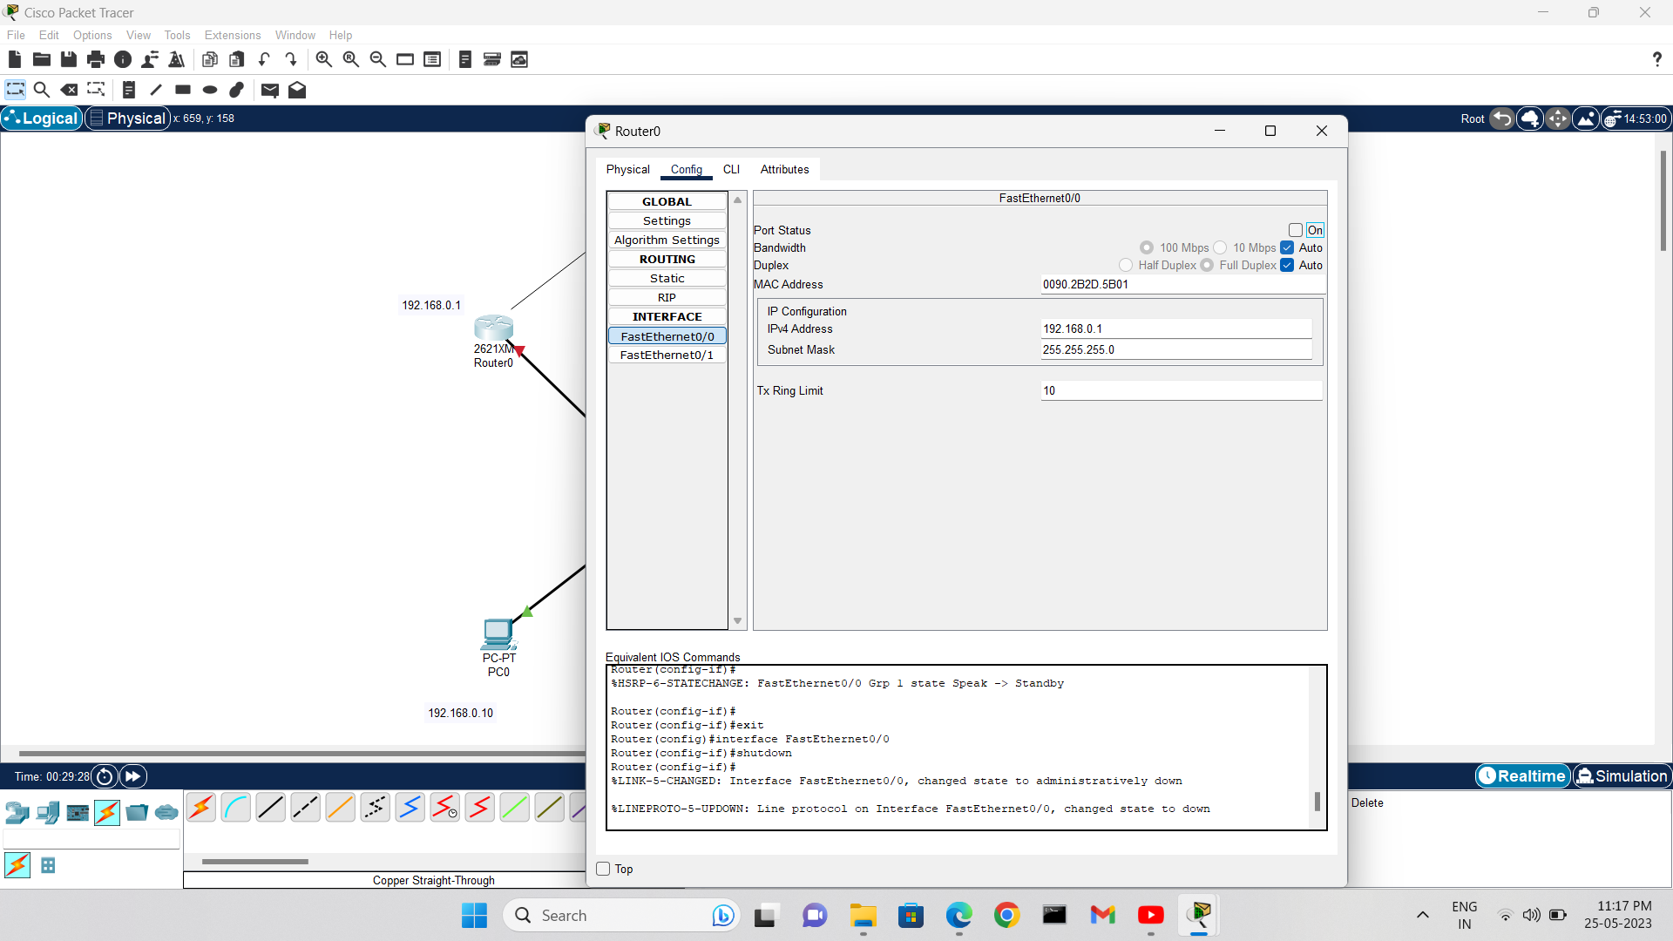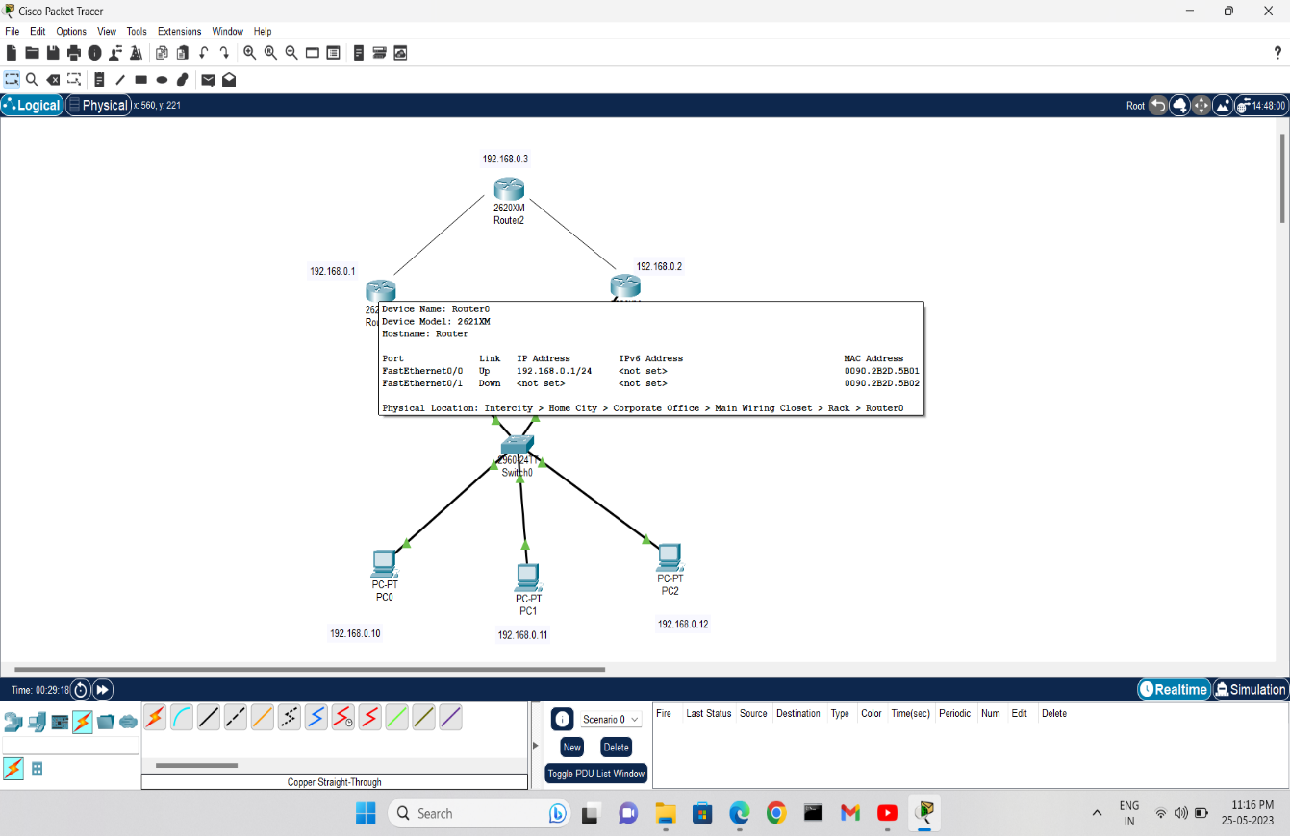

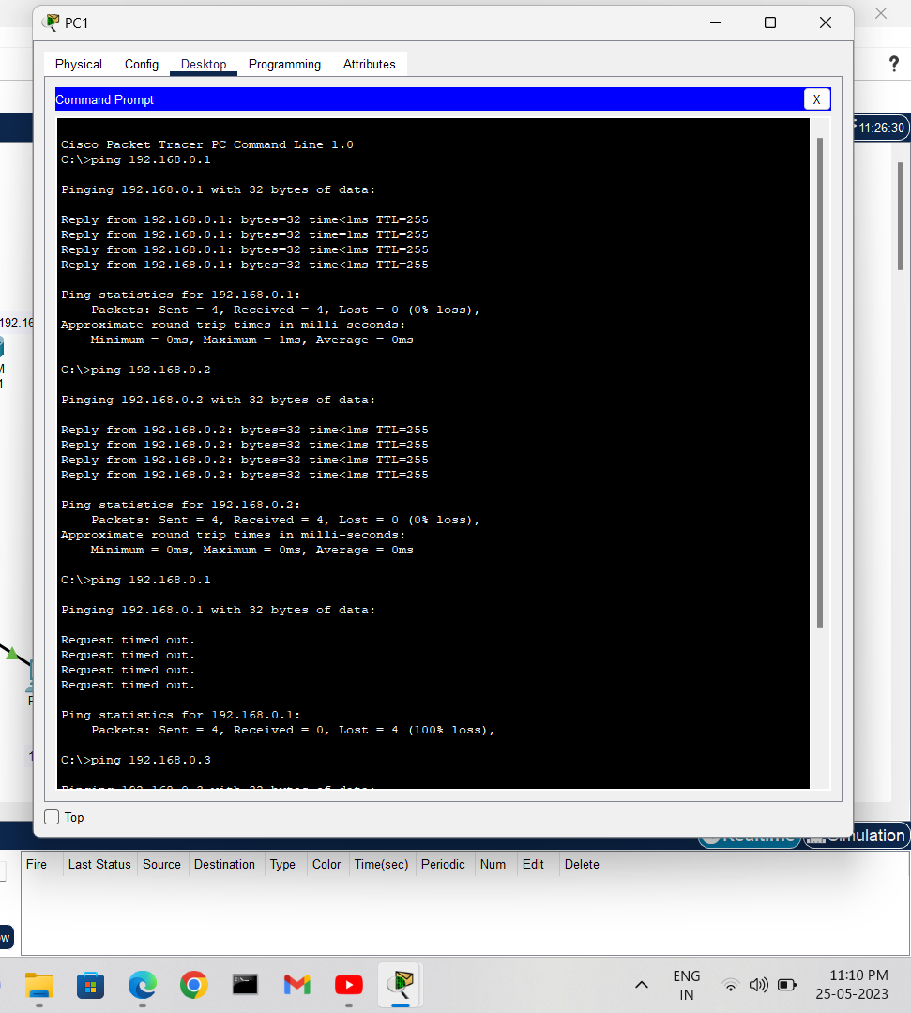**STEP 15:** To check the working of our standby router click on a router in the network and switch off the port.

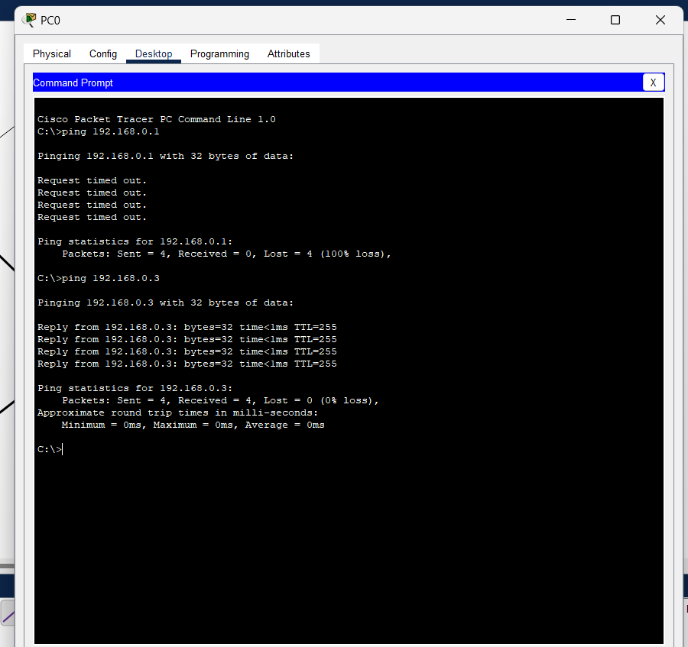**STEP 16 :** We can notice that there is an error in the transmission of data because of error in the transmission channel.

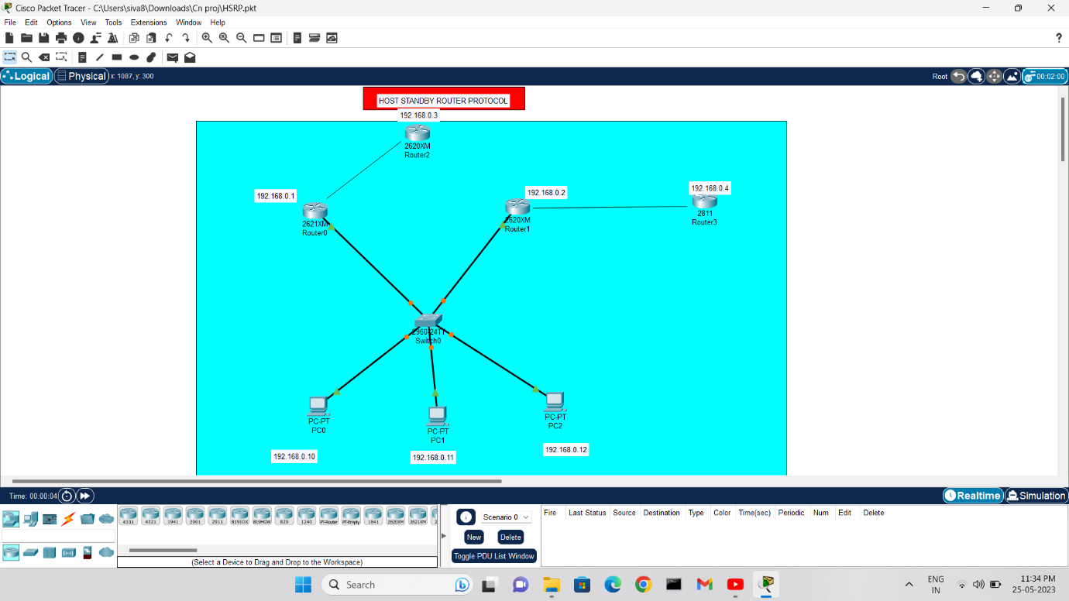**STEP 17:** Here we can see that our standby router is still working and accepting the data packets without any physical connection with the network.

Similarly we can add ‘n’ standby routers for our network and use them accordingly.

**RESULT:**

We conducted an implementation of HSRP (Hot Standby Router Protocol) in our computer network using Cisco Packet Tracer. The purpose was to enhance network reliability by providing automatic failover and high availability. Here are the results of our implementation:

1. Pre-Implementation Analysis: Prior to implementing HSRP, our network experienced frequent downtime due to a single point of failure in our router setup. This created disruptions and affected network performance.

2. HSRP Configuration: In Cisco Packet Tracer, we configured HSRP on our primary and backup routers. The primary router was designated as the active router, while the backup router was set to standby mode. We assigned a virtual IP address to the HSRP group, ensuring seamless failover.

3. Failover Testing: After the HSRP configuration, we conducted failover testing to assess the performance of our implementation. We simulated a failure by shutting down the primary router's interface.

4. Automatic Failover: During the failover test, the backup router promptly detected the failure of the primary router and took over the active role without any manual intervention. It seamlessly started forwarding traffic using the virtual IP address assigned to the HSRP group.

5. Minimal Downtime: The failover process was extremely fast, resulting in minimal downtime. Users connected to the network did not experience significant disruptions during the failover.

6. Network Performance: We closely monitored the network performance during the failover. Although there was a slight delay in traffic forwarding during the transition, it was well within acceptable limits. The failover process did not cause any significant impact on network performance or user experience.

7. Enhanced Reliability: The implementation of HSRP has significantly improved our network's reliability. In case of a router failure, the backup router automatically assumes the active role, ensuring uninterrupted network connectivity for users.

Overall, the implementation of HSRP in our computer network using Cisco Packet Tracer has proven to be a successful solution. It has provided us with automatic failover capabilities, high availability, and enhanced network reliability.

We are confident that HSRP will continue to minimize disruptions caused by router failures, ensuring a stable and robust network infrastructure for our organization.

**Conclusion:**

The mini project successfully demonstrated the implementation and functionality of Hot Standby Router Protocol (HSRP). The configuration and testing confirmed the failover capability of HSRP, ensuring uninterrupted network connectivity in case of a router failure. HSRP provides a reliable and efficient solution for achieving network redundancy and high availability.